
Instructions for Virtual Reality Experience – Oculus Go
Oculus Go Includes:
- Headset: adjustable straps to get the right fit for your head, a jack for charging and another for headphones. On the top of the unit is the power button and volume control.
- Controller: there are three buttons are on the controller, on top there is a back and an oculus button and on the front (or by the index finger) is the enter button.
- Headphones: connect using the jack on the left side of the headset.
- Charging Cord
Turn On
Turn the unit on by pressing on the power button at the top of the headset. The first screen will prompt you to use the remote and hold down the oculus button, which is the one that has the oval shape underneath the arrow (back) button. This will enter you into the Virtual Reality (VR) home screen.
Charging
Make sure the unit is charged. You can check the charge on the unit by navigating to the home screen. Look down at the tool bar that starts with “Home”. On the far right above the “Search” function you will see two percentages. The first is the battery life if the remote and the second is the headset charge. If the charge is low, plug it in.
If at any time the headset has any problems loading the home screen or the video is not playing properly, hold the power button down until you are prompted with a selection to Turn off, Restart, or Go Back. Choose Restart. Remember this is a computer, and sometimes it just needs to reboot to refresh itself.
Getting the Video Started
First you should know each headset and control have a number shared between them. The number on the headset is under the side strap. The controller will only work with the correlating headset.
Once you’ve powered on you should be on the home screen. You will know because you will see a large black box that says “Recent.” Here you should see the video 6x9 A virtual reality of solitary confinement. To navigate use the remote, much like a laser pointer, point on the 6x9 video and tap on the large front button with your index finger.
If you do not see the video, look down at the toolbar use the remote and click on “Library”, which is second from the left. You should then see the video listed. Click on it to get it started.
Once you’ve clicked on the video it will load and lead you to a warning screen to make sure the participant is at least 18 years old and they understand what they are viewing. Once the participant has read the warning use the remote and tap the button on the front with your index finger.
The video should begin playing. If there are any issues with the video, for instance while the audio is playing and the participant doesn’t see the video, please have them use another unit and shutdown/restart the unit that has the issue.
Preparing the Participant
Volunteers should mention the app is voiced, and co-created by people who have experienced solitary.
Before a participant puts on the headset ask them the following questions:
- Have they used virtual reality before?
  - YES! They may have a sense a sense for how real it can feel, but make sure they are aware this experience may be different. See question 2.
  - NO! You will want to prepare them for the VR experience by encouraging participants to look around. This is an interactive experience which means the video responds to where the user looks, for instance letters will appear on the bed and when you focus on them the user will hear a personal experience.
- Do they experience motion sickness or claustrophobia?
  - If they answer yes, let them know that the VR might bring up those feelings. If they want to continue assure them that at any point they can take the headset off or hold onto the chair or table for stability. For any reason they cannot get the unit off themselves let them know to simply raise their hands and you will help them.
- Are they at least 18 years old?
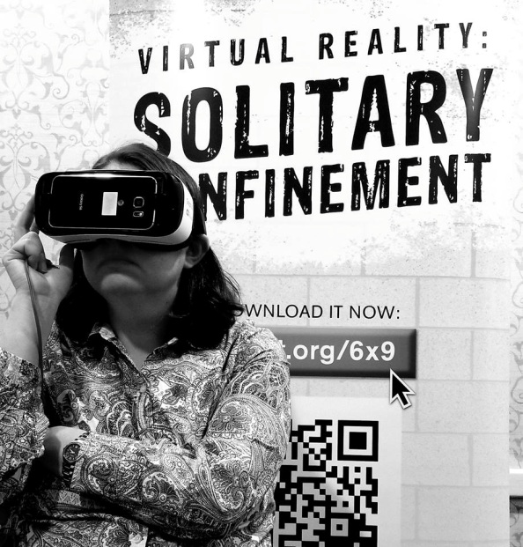
  - If not, they need a parent or guardian’s permission
Guidelines
As the facilitator you will want to make sure the headphones are plugged in to the headset before handing over the unit to the participant.
You should queue up the video to the warning screen and ask them to read it before pressing the enter button on the top of the remote by the index finger.
Please make sure the participant is seated in a chair before beginning the video.
Instruct everyone not using VR to not touch the participant during the VR experience. This includes family & friends who may be accompanying the participant. This experience can often be intense and people can be startled.

Booth Set Up
Display stickers, pins, and provided NRCAT materials on the table
If the banner is provided place a chair for a VR participant is in front of it for photos ops (see photo)
A power strip and outlet are important for charging the headsets
Two to four chairs available for VR participants while using the headset

